1. Introduction
   1. Client side language
   2. 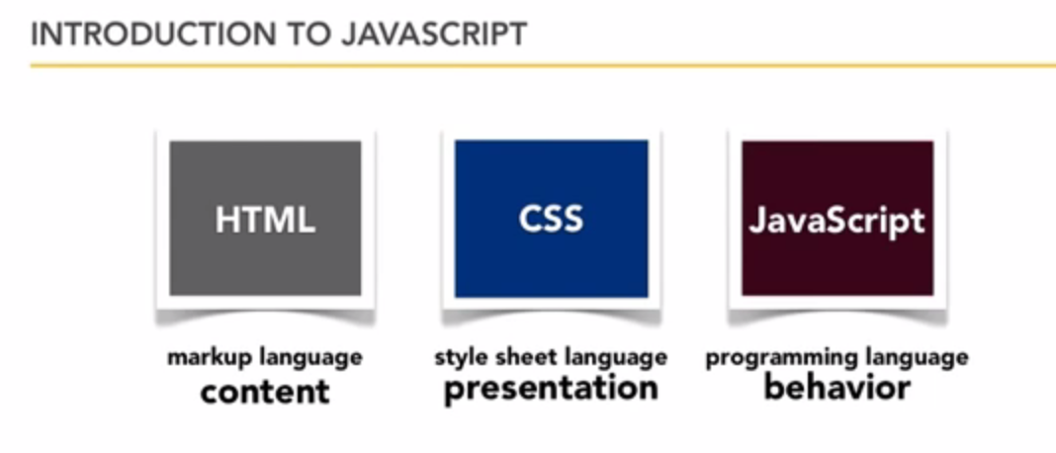
   3. 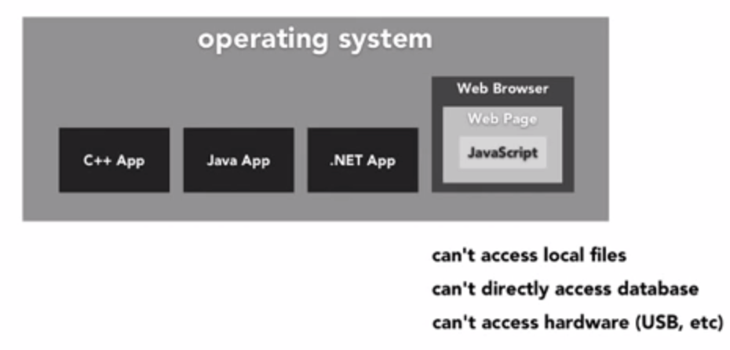
   4. Java script works only inside web browser and not in local system
   5. 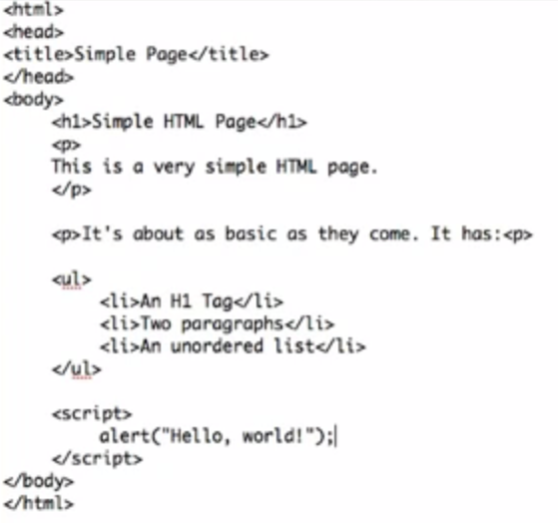
   6. Sample code above.
   7. No default script editor can be used along with the web site editor which we normally use.
   8. Introduction to fire bug.
2. Cont
   1. 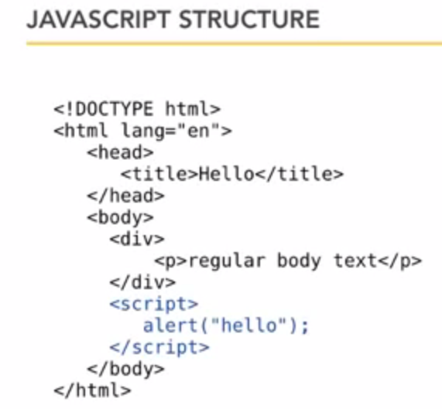
   2. Case sensitive
   3. Java script is white space in sensitive.
   4. 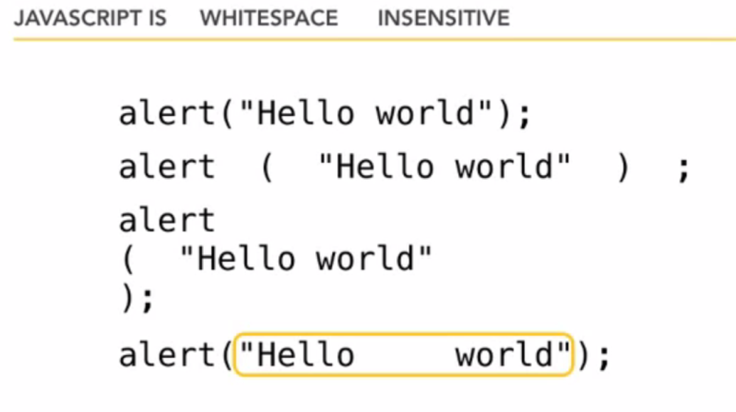
   5. JavaScript comments
   6. 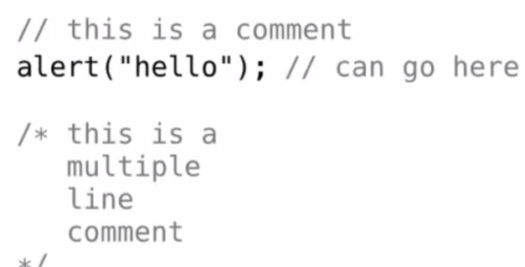
   7. If the script tag is placed inside the body tag, the page is loaded first and then the script is executed, if it is placed inside the head tag the script is executed first and then the page is loaded. If used in a head section the page loading time will be increased.
   8. 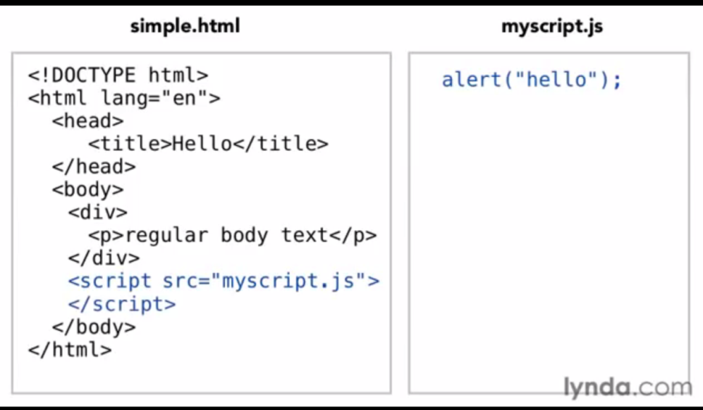
   9. Variables
      1. Var <name>;
   10. Conditional code
       1. 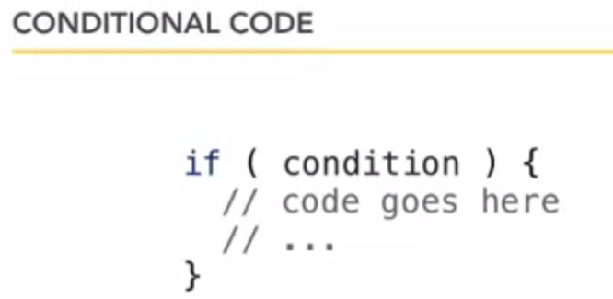
   11. Arithmetic operators
   12. 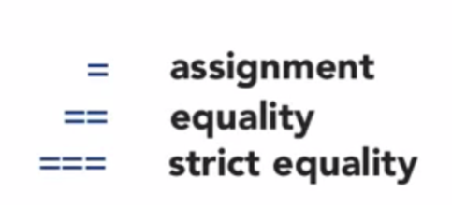
   13. Strict equality means value and type both same
   14. Console.log is used to log the message (log, warn, error)
   15. Looping – for , while
   16. Function and function usage
   17. 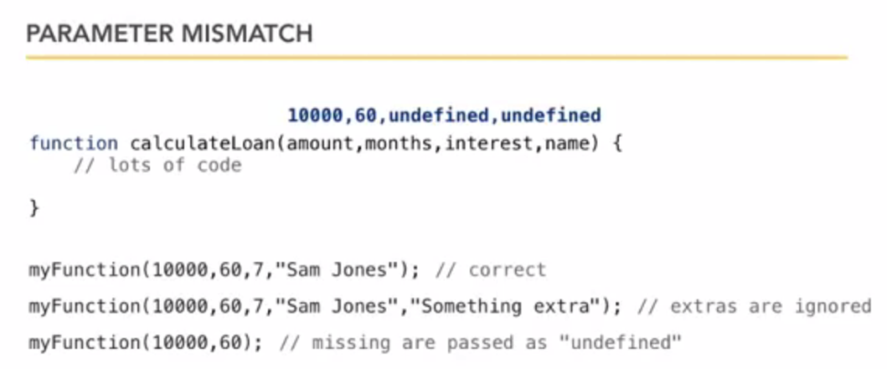
   18. Scope of a variable
3. Cont
   1. Creating array
   2. Assign different values to diff index
   3. 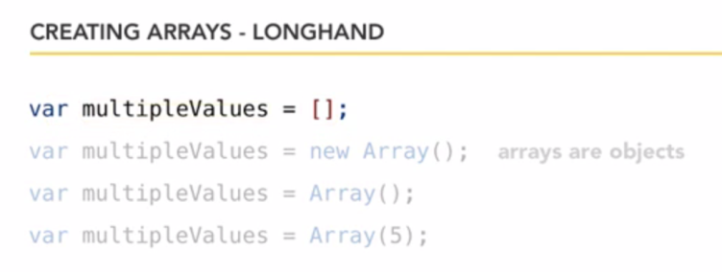
   4. NAN
   5. Math functions
   6. 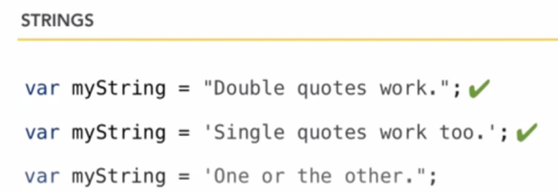
   7. Escape char is use for using quotes
   8. String functions
   9. 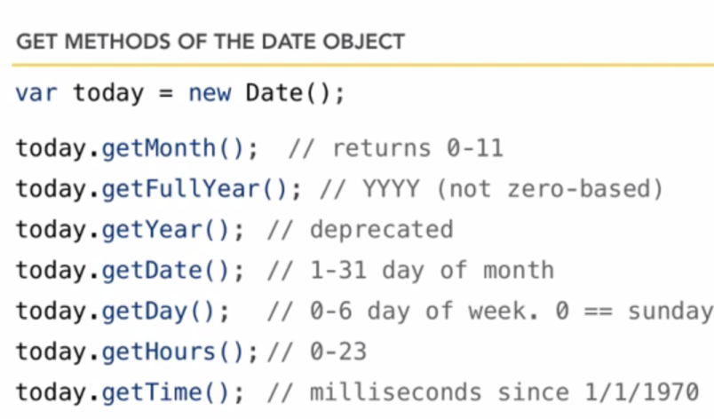
   10. 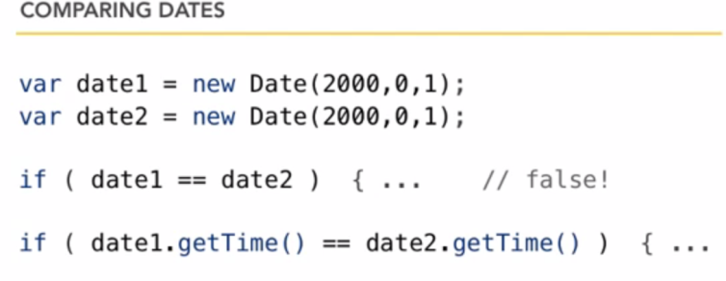
   11. 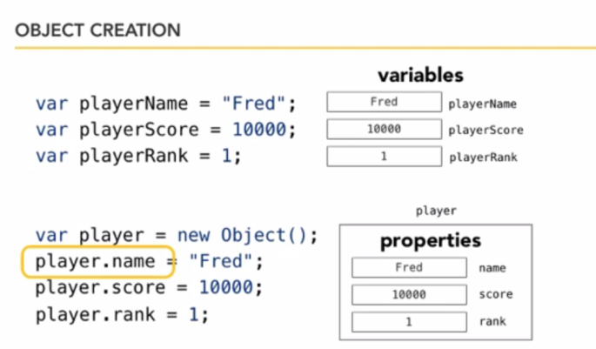
   12. 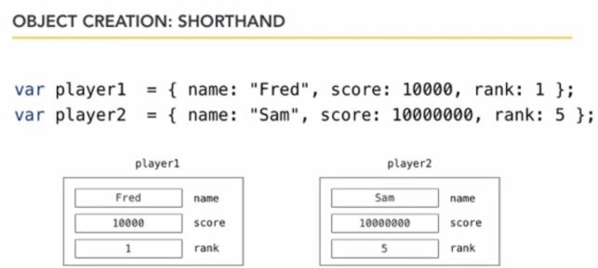
   13. 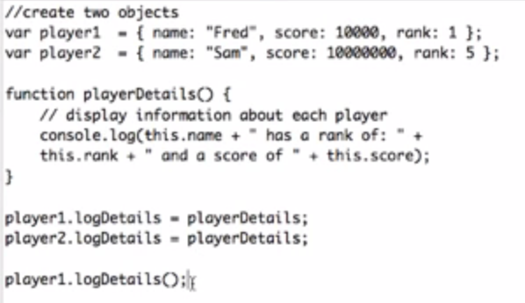
4. DOM
   1. 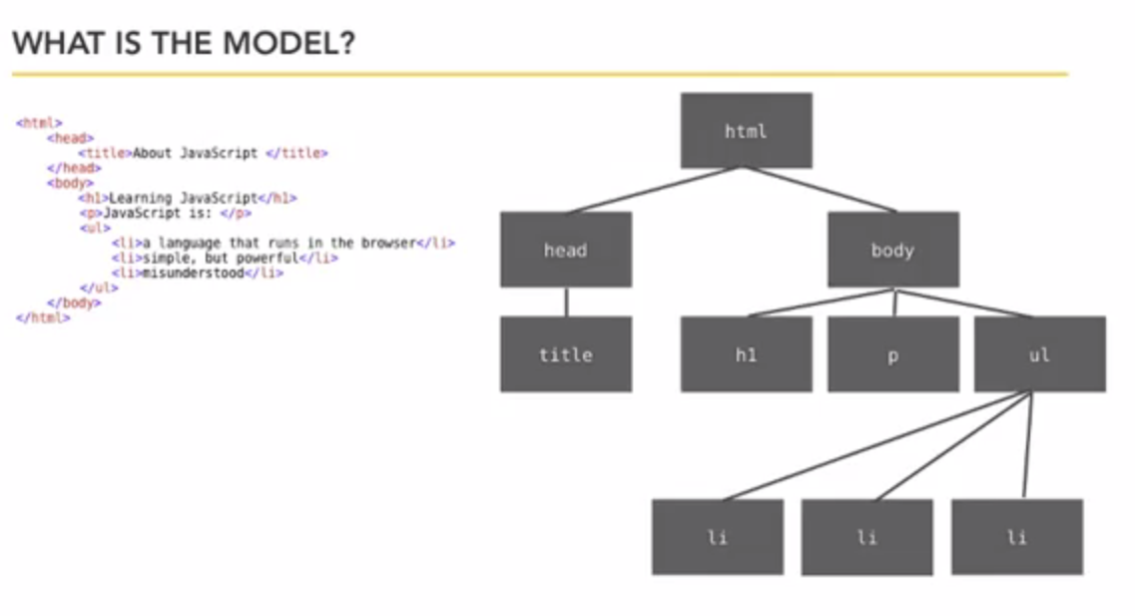
   2. 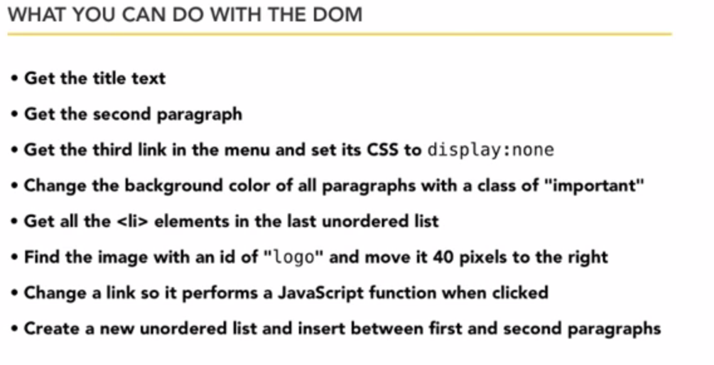
   3. 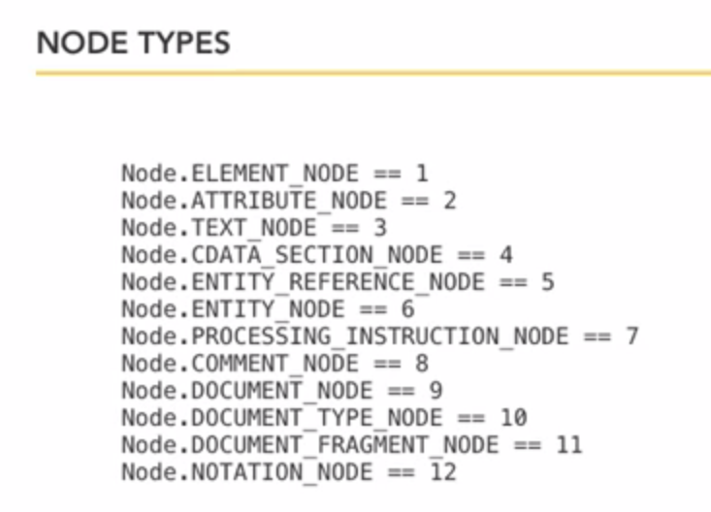
   4. First 3 only important
5. Cont
   1. 
   2. 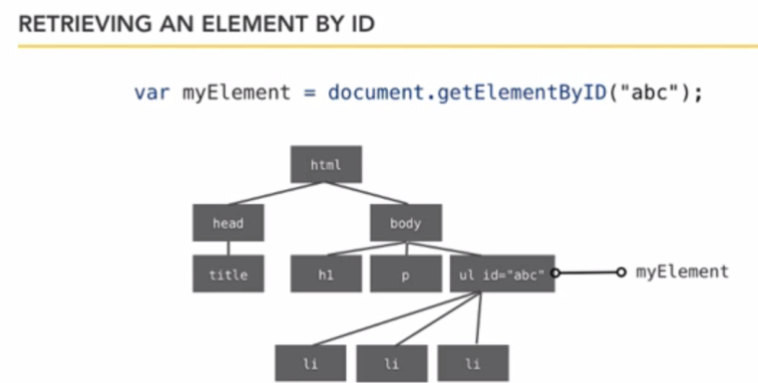
   3. 
   4. 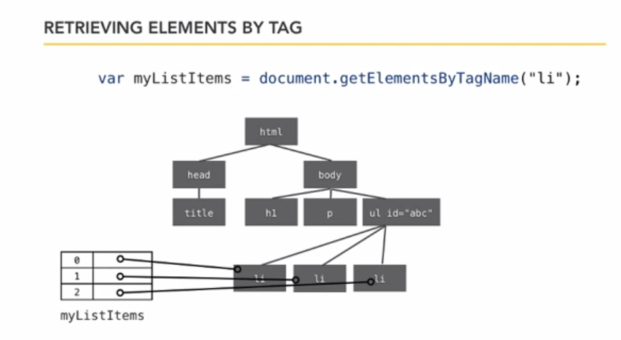
   5. 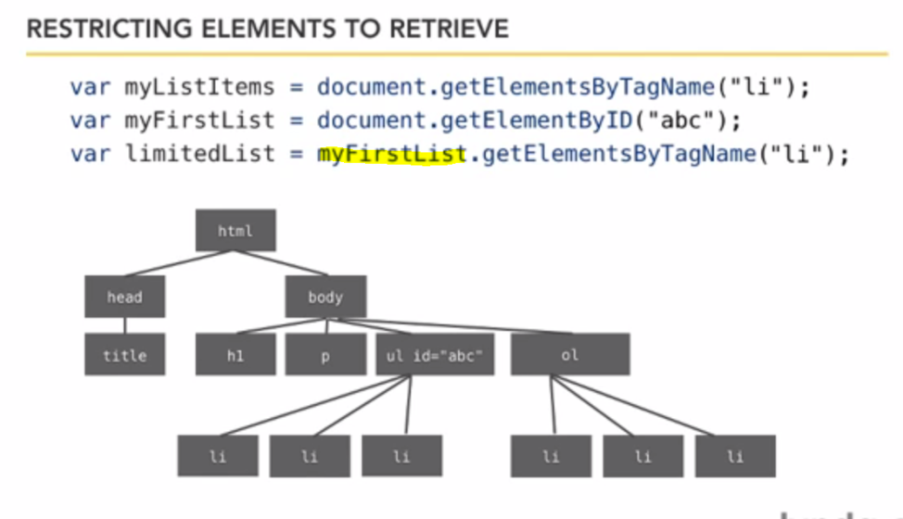
   6. 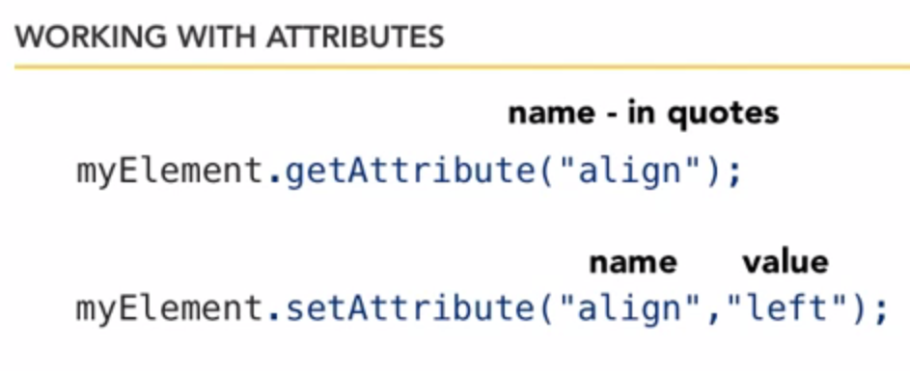
   7. 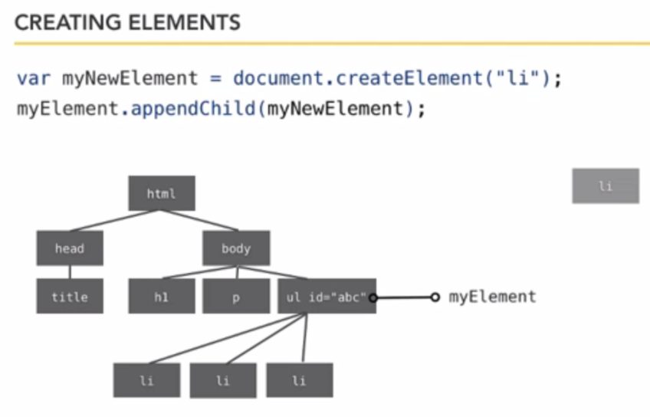
   8. 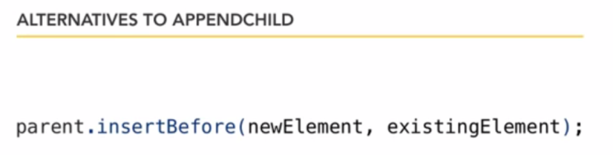
6. Events and listeners
   1. 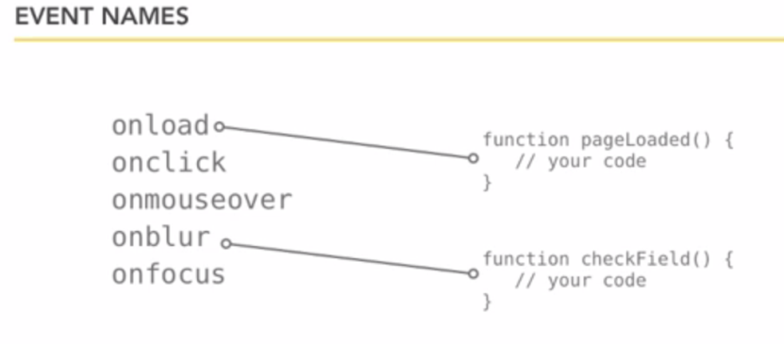
   2. 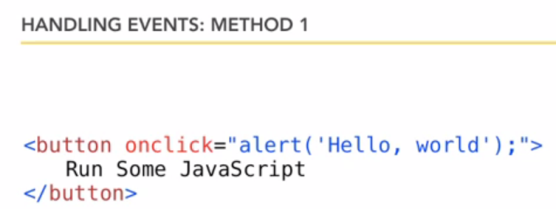
   3. 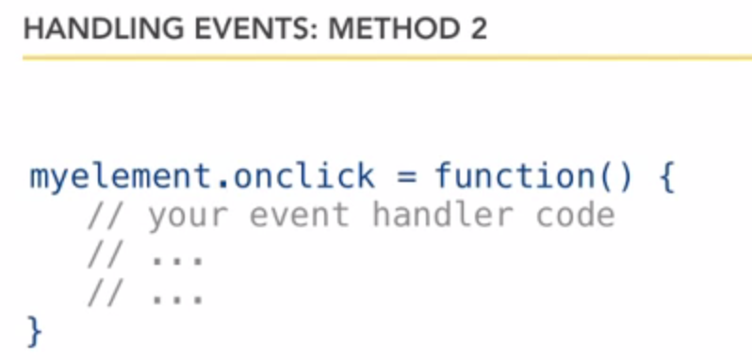
   4. 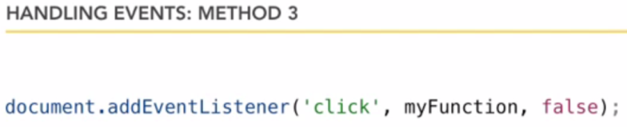
7. How to use fire bug, some generic functions and error we commit in javascript
8. Smart forms
   1. Getting form and form elements
   2. If we return false from a JS the page submit event will be cancelled.
9. CSS Properties
   1. 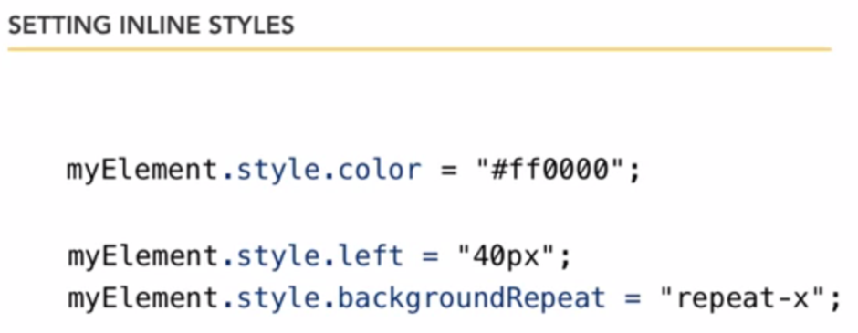
   2. 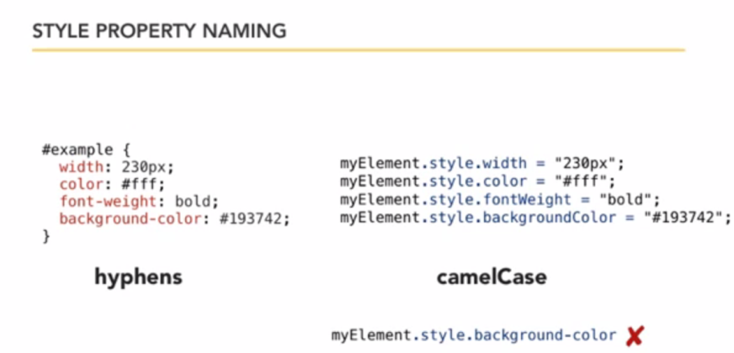
   3. Sample Java script to display annoying frame when page loads
   4. 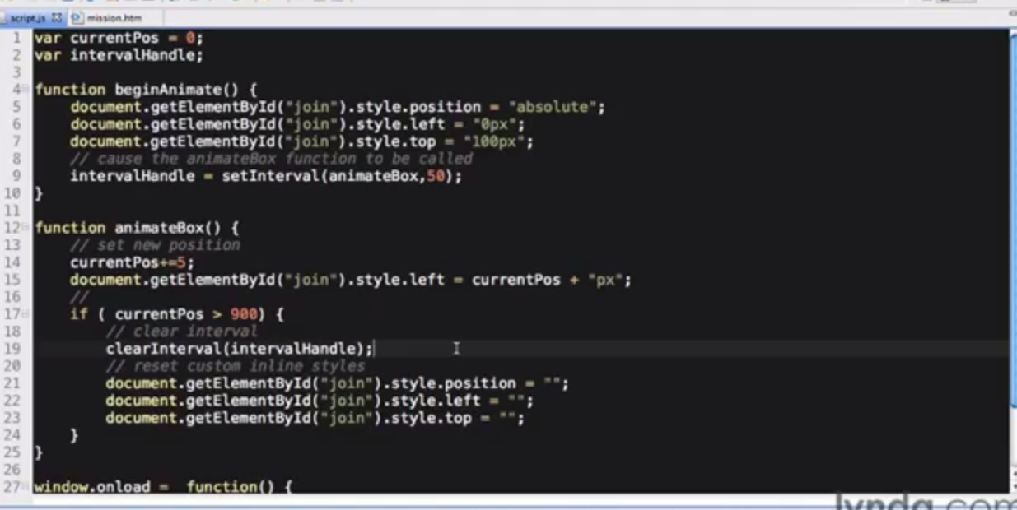
10. JS best practices
    1. 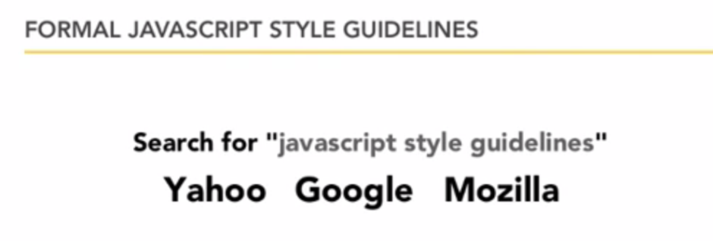
    2. JS minification
    3. 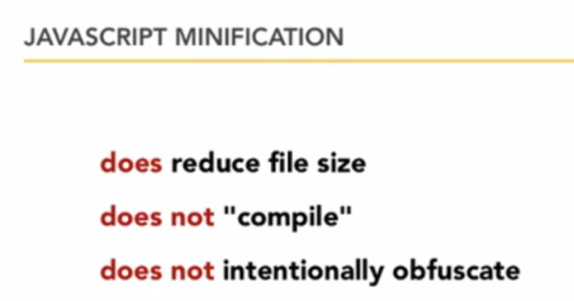
    4. 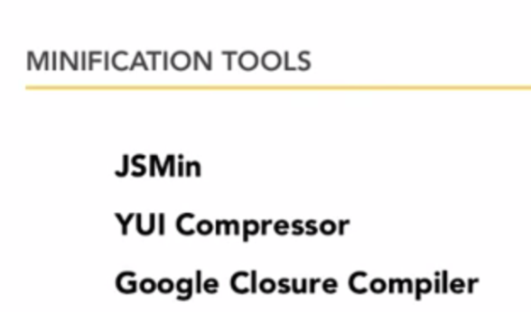
11. Java Script Libraries
    1. JQuery –
    2. LightBox - for implementing images
    3. Moo.fx
    4. CurvyCornners
    5. Script.aculo.us
    6. Linking a JS file
    7. 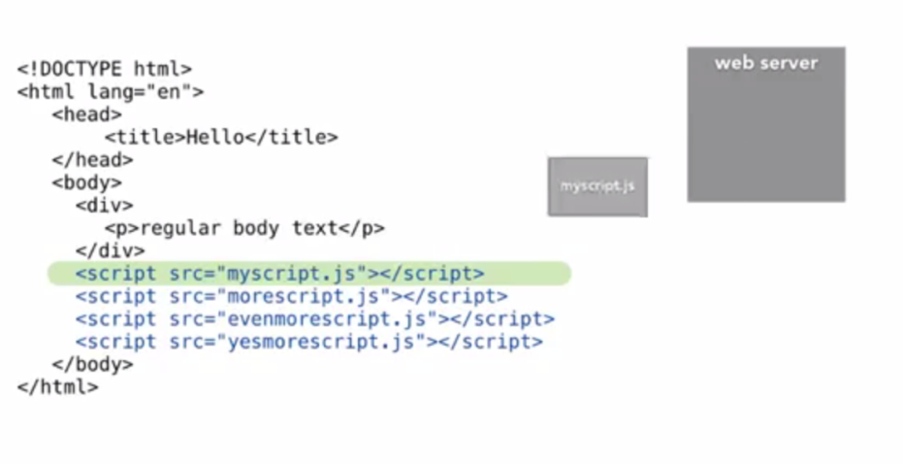
    8. For every file will be given a separate request and will be downloaded to local.So combine yr JS file to a single one and use
12. Java script to avoid
    1. Use inner html rather than document .write becz of browser compablity
    2. 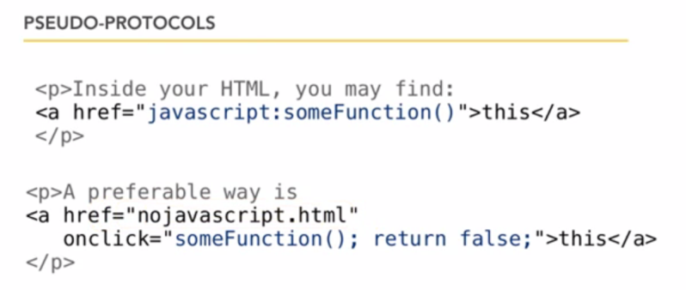
    3. String pattern in JS
    4. AJAX

# Beginner Java Script

1. Beginner JavaScript Tutorial - 1 - Introduction to JavaScript
   1. 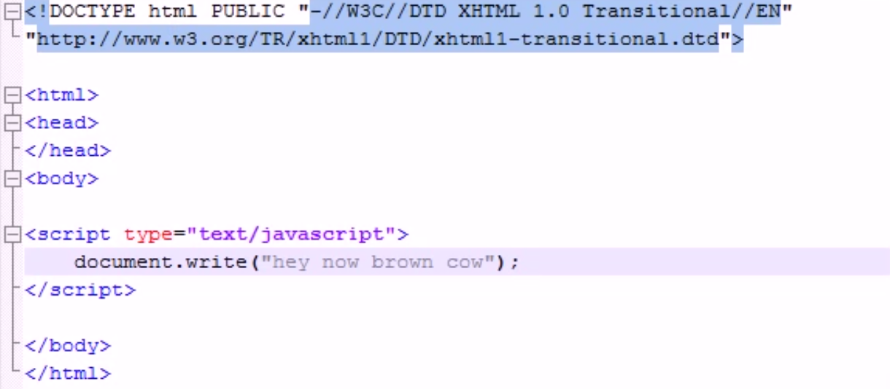
2. Beginner JavaScript Tutorial - 2 - Comments and Statements
   1. 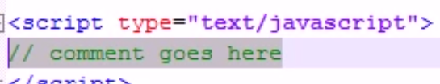
   2. 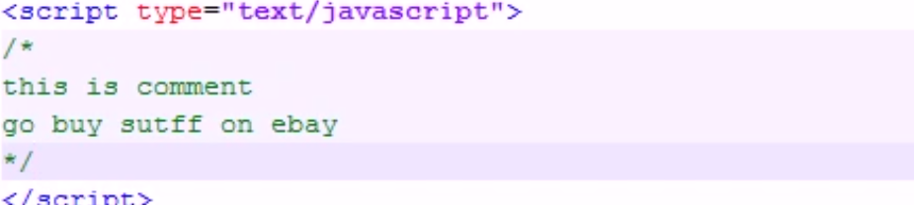
   3. 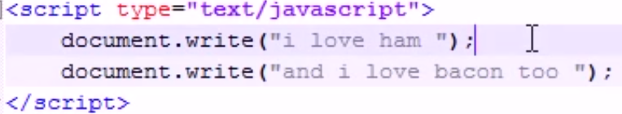
3. Beginner JavaScript Tutorial - 3 - Variables
   1. 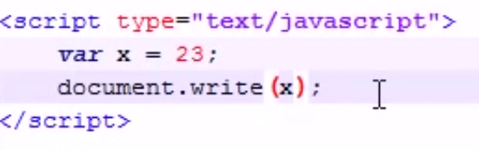
4. Beginner JavaScript Tutorial - 4 - Different Types of Variables
   1. 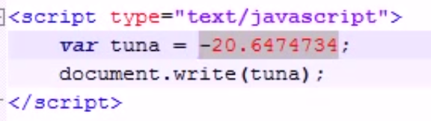
   2. 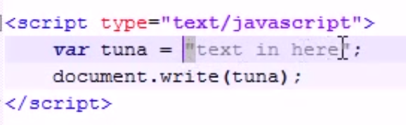
   3. 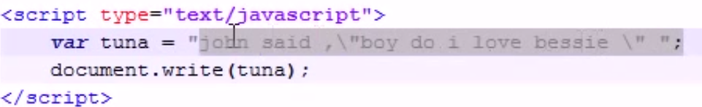
5. Beginner JavaScript Tutorial - 5 - Using Variables with Strings
   1. 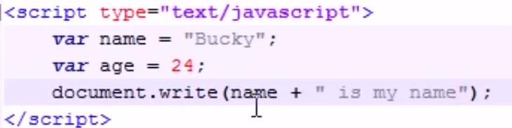
6. Beginner JavaScript Tutorial - 6 - Functions
   1. 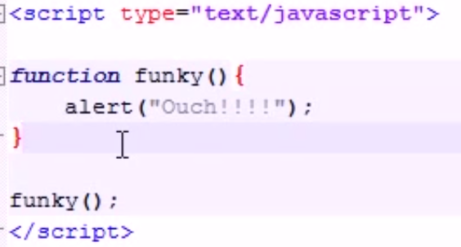
   2. 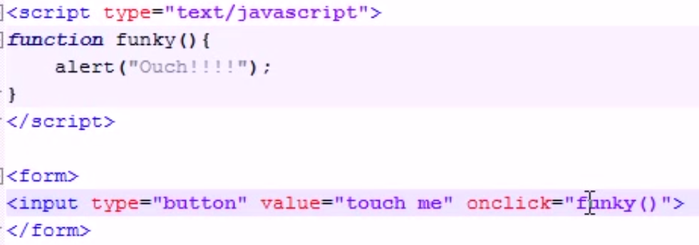
7. Beginner JavaScript Tutorial - 7 - Using Parameters with Functions
   1. 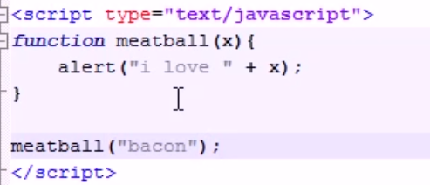
8. Beginner JavaScript Tutorial - 8 - Functions with Multiple Parameters
   1. 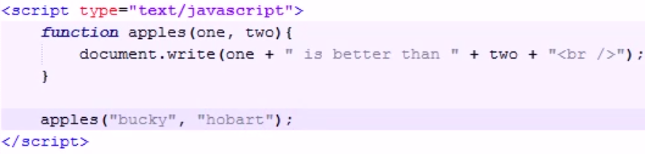
9. Beginner JavaScript Tutorial - 9 - The return Statement
   1. 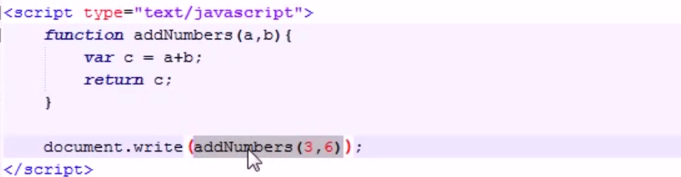
10. Beginner JavaScript Tutorial - 10 - Calling a Function From Another Function
    1. 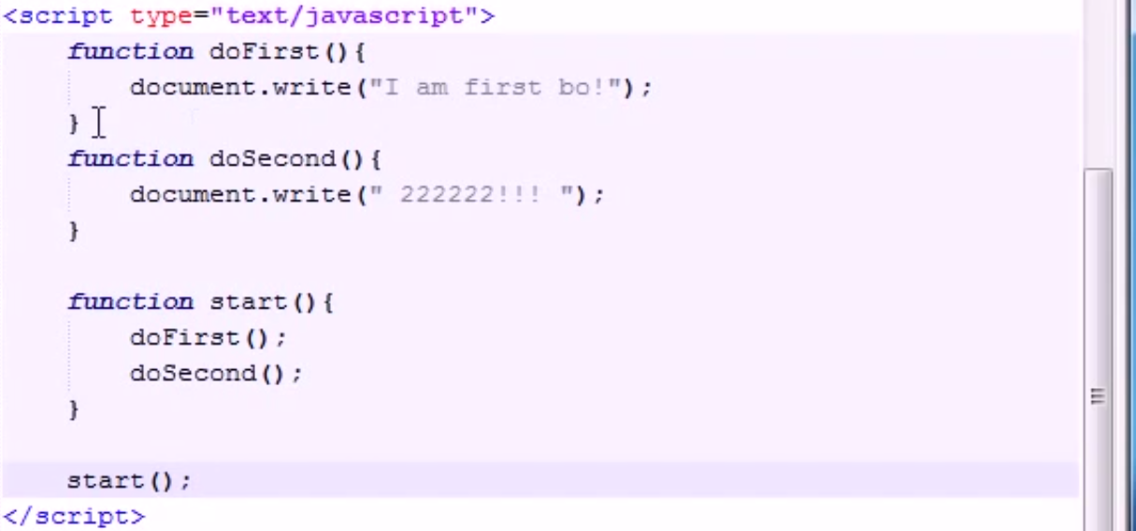
11. Beginner JavaScript Tutorial - 11 - Global & Local Variables
    1. 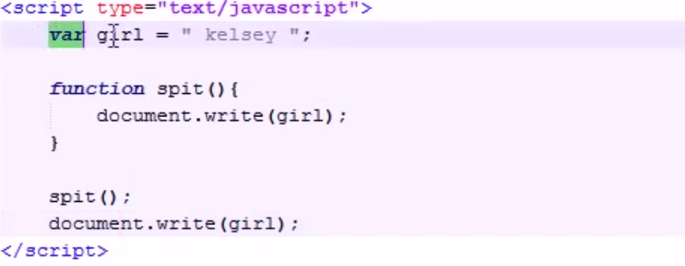
    2. 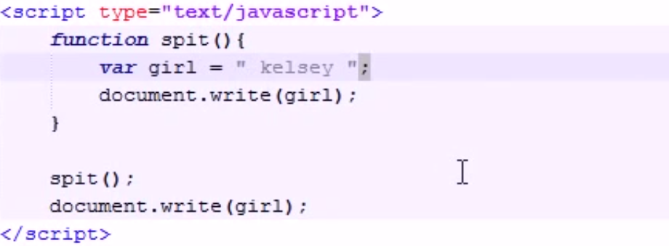
12. Beginner JavaScript Tutorial - 12 - Math Operators
    1. 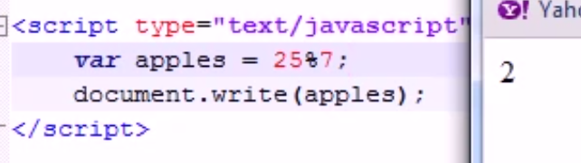
13. Beginner JavaScript Tutorial - 13 - Assignment Operators
    1. 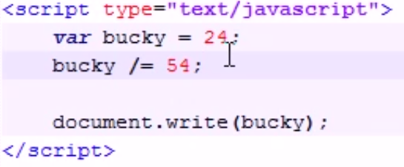
14. Beginner JavaScript Tutorial - 14 - if Statement
    1. 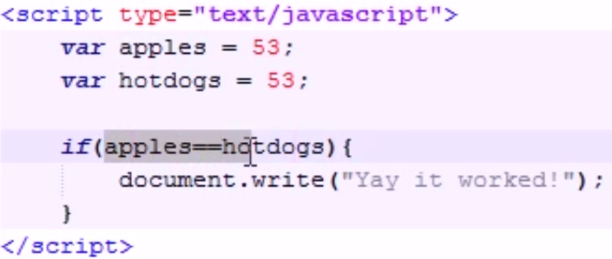
    2. 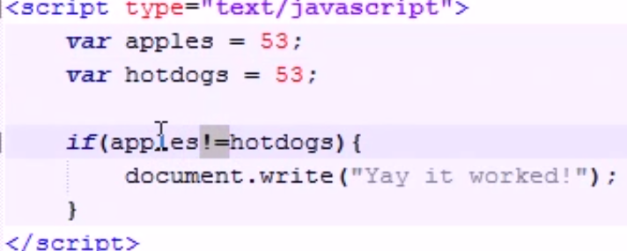
15. Beginner JavaScript Tutorial - 15 - if else Statement
    1. 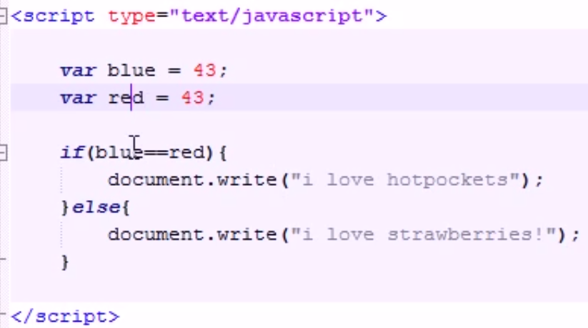
16. Beginner JavaScript Tutorial - 16 - Nesting and Fridays!
    1. 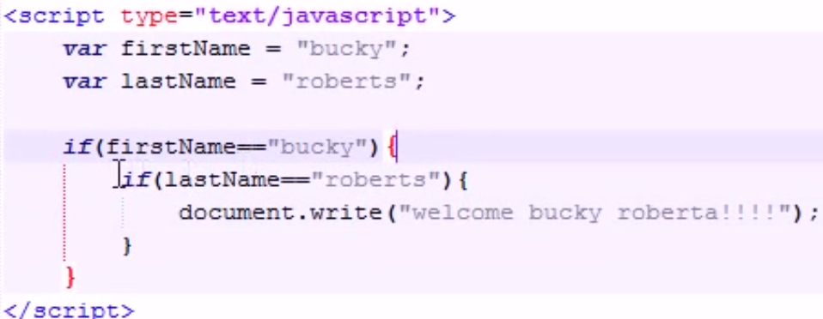
17. Beginner JavaScript Tutorial - 17 - Complex Conditions
    1. 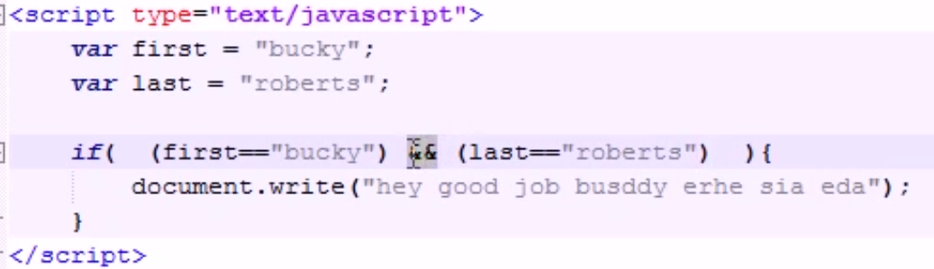
18. Beginner JavaScript Tutorial - 18 - switch
    1. 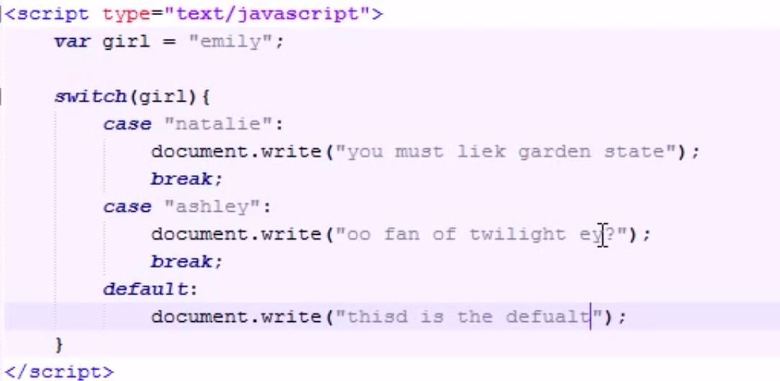
19. Beginner JavaScript Tutorial - 19 - for Loop
    1. 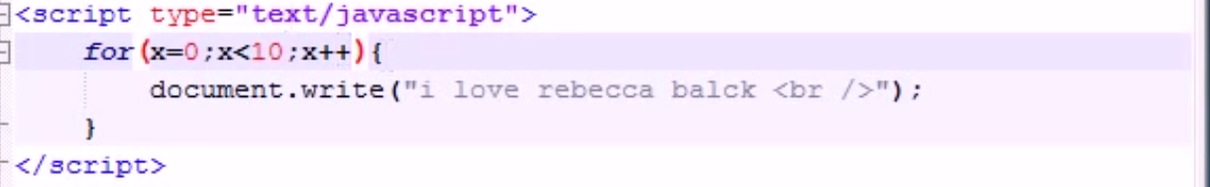
20. Beginner JavaScript Tutorial - 20 - while Loop
    1. 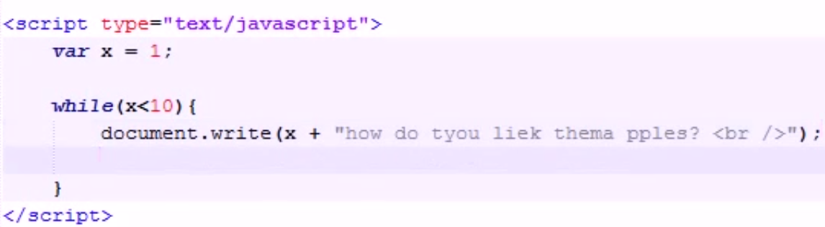
21. Beginner JavaScript Tutorial - 21 - do while
    1. 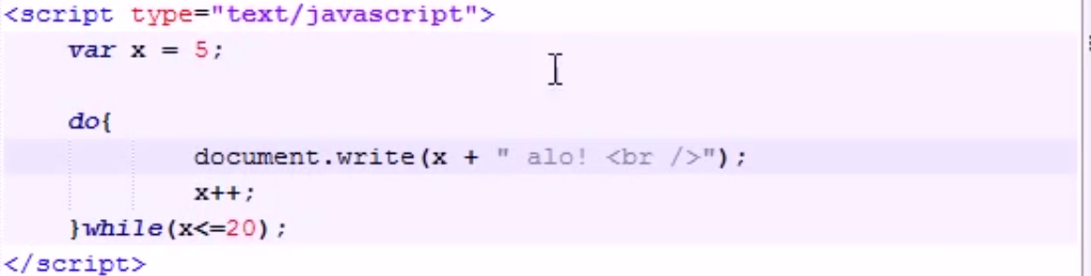
22. Beginner JavaScript Tutorial - 22 - Event Handlers
    1. 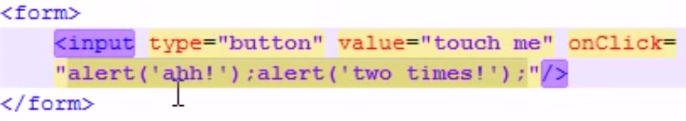
23. Beginner JavaScript Tutorial - 23 - onMouseOver & onLoad
    1. 
    2. 
    3. 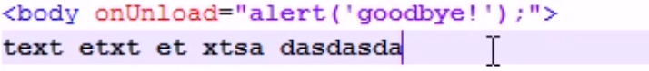
24. Beginner JavaScript Tutorial - 24 - Objects
    1. 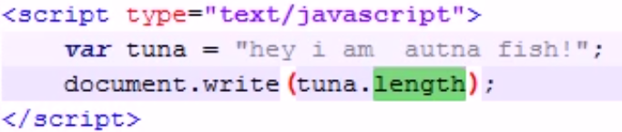
25. Beginner JavaScript Tutorial - 25 - Creating Our Own Objects
    1. 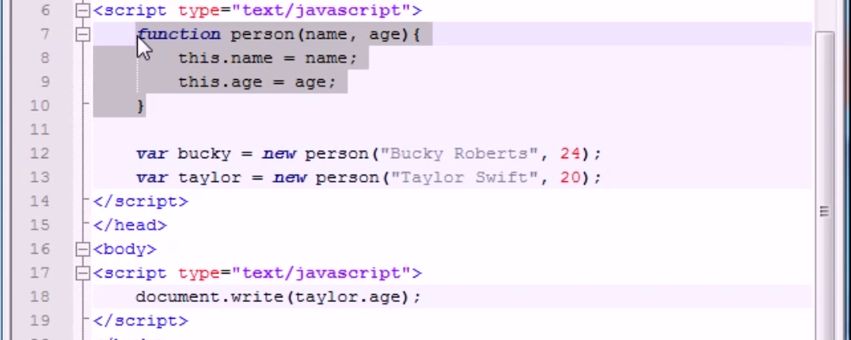
26. Beginner JavaScript Tutorial - 26 - Object Initializers
    1. 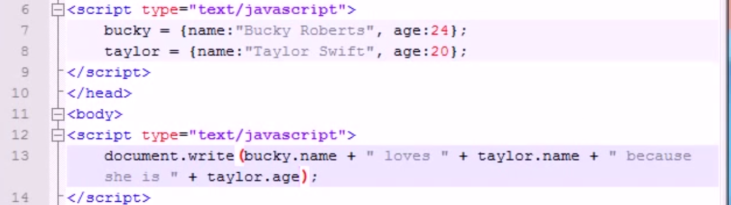
27. Beginner JavaScript Tutorial - 27 - Adding Methods to Our Objects
    1. 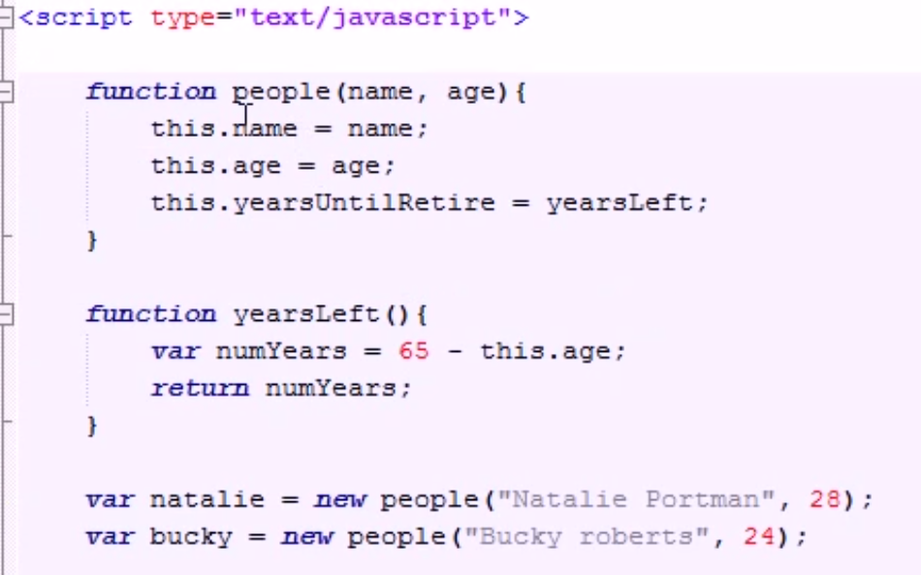
    2. 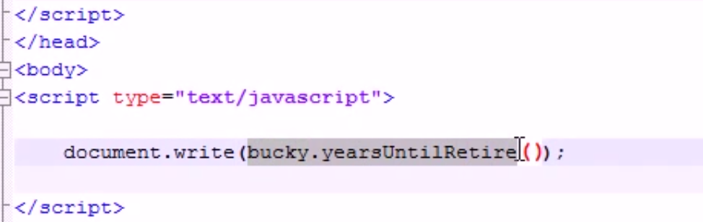
28. Beginner JavaScript Tutorial - 28 - Arrays
    1. 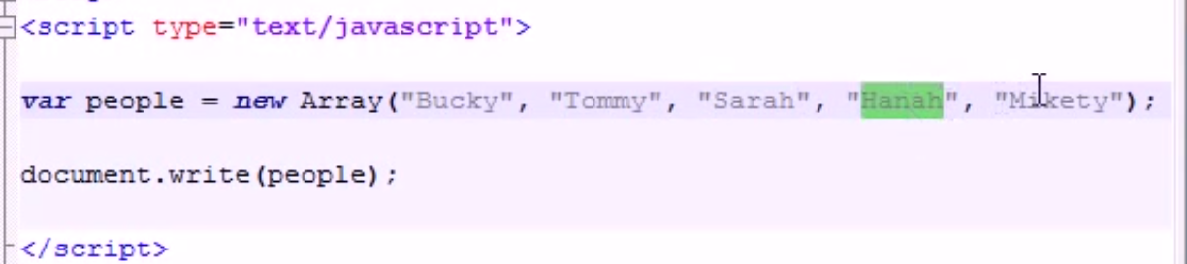
    2. 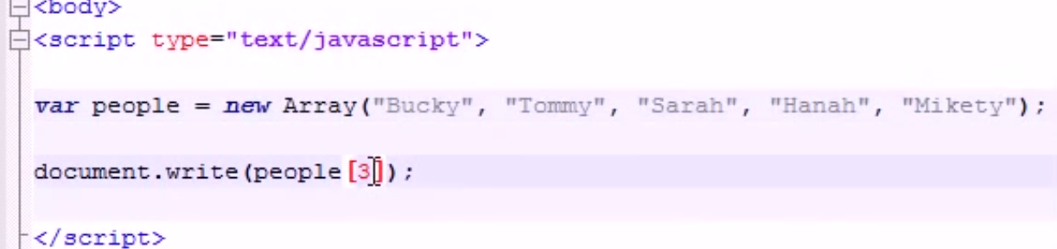
    3. 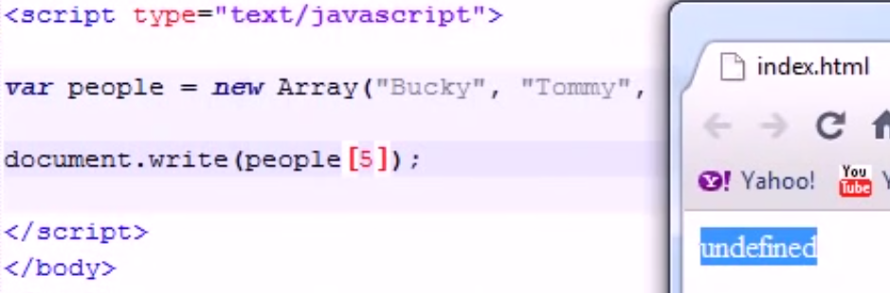
29. Beginner JavaScript Tutorial - 29 - Other Ways to Create Arrays
    1. 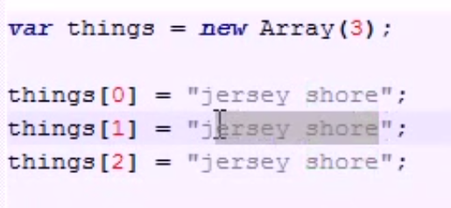
    2. 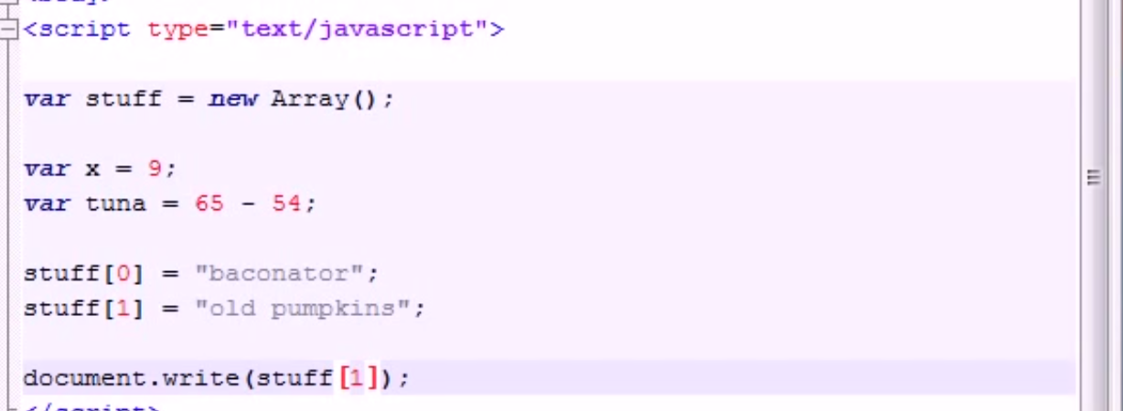
30. Beginner JavaScript Tutorial - 30 - Array Properties and Methods
    1. 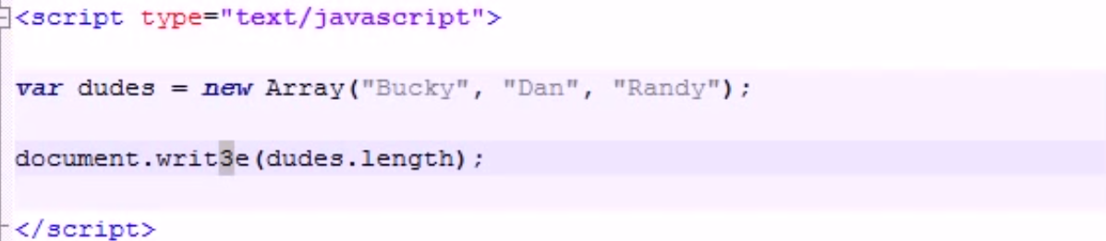
    2. 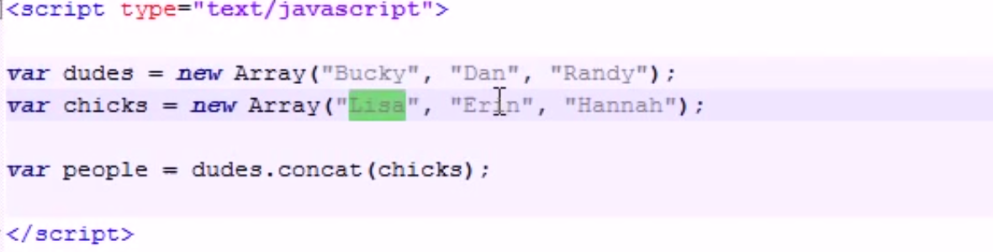
31. Beginner JavaScript Tutorial - 31 - join and pop
    1. 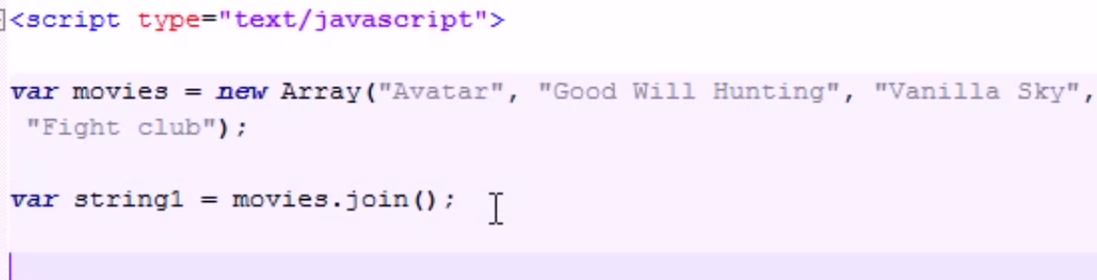
    2. 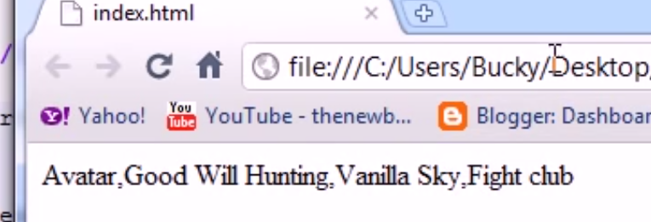
    3. 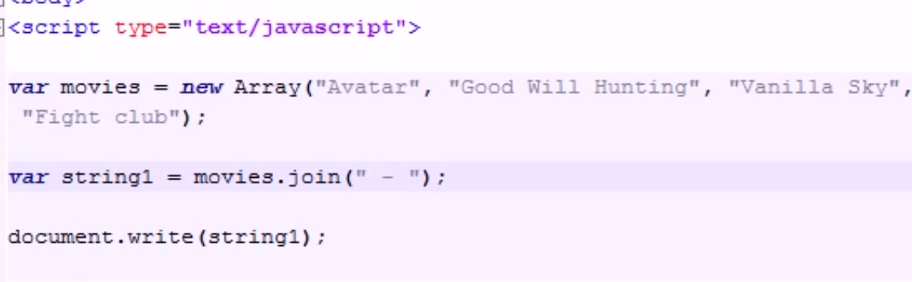
    4. 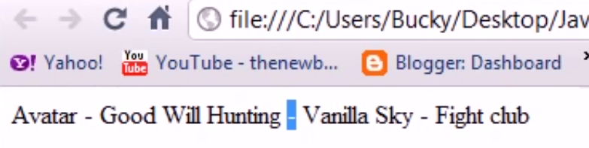
    5. 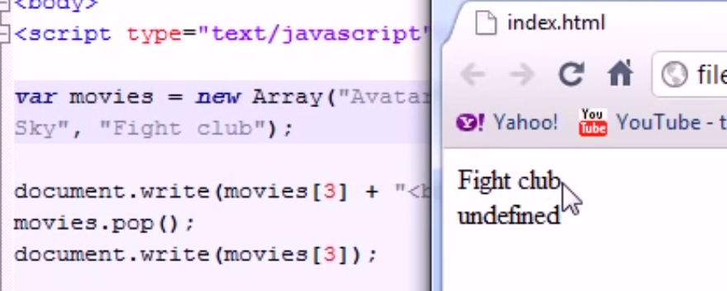
    6. Pop - this method deletes the last element of the array
32. Beginner JavaScript Tutorial - 32 - reverse, push, sort
    1. 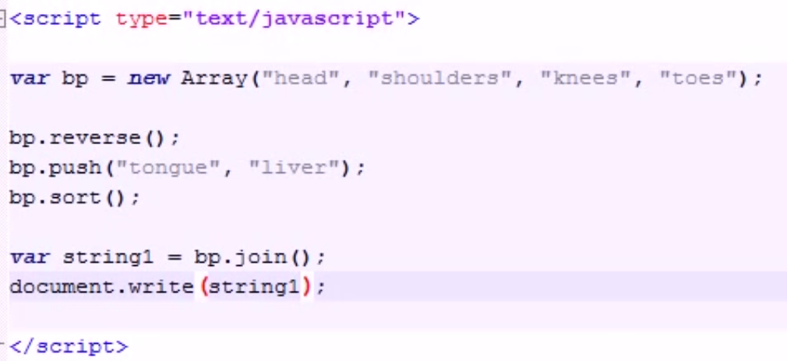
    2. 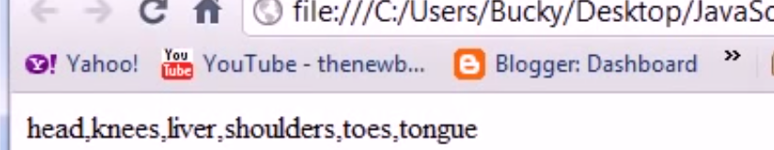
33. Beginner JavaScript Tutorial - 33 - Add Array Elements Using a Loop
    1. 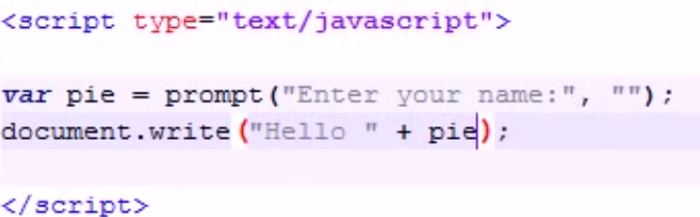
    2. 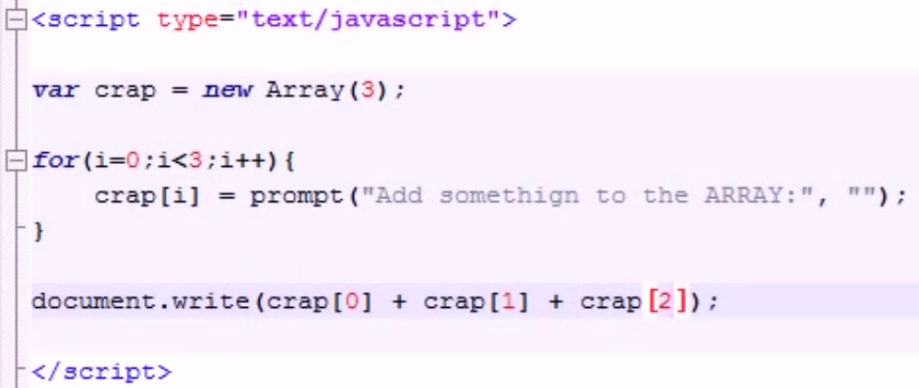
34. Beginner JavaScript Tutorial - 34 - Cool Technique to Print Array Elements
    1. 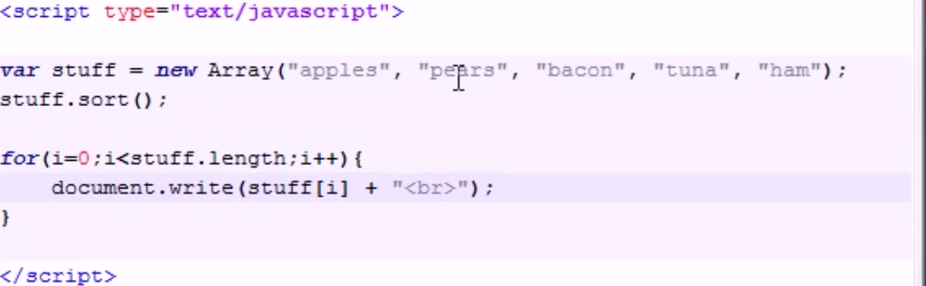
35. Beginner JavaScript Tutorial - 35 - Associative Arrays
    1. 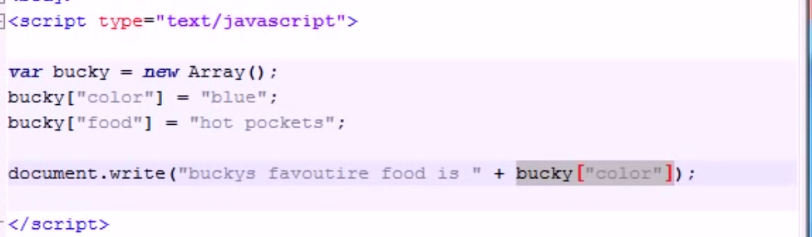
36. Beginner JavaScript Tutorial - 36 - Math Objects
    1. 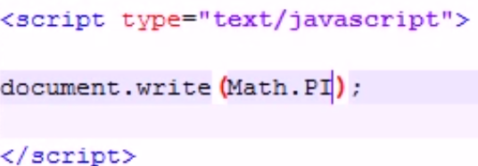
    2. 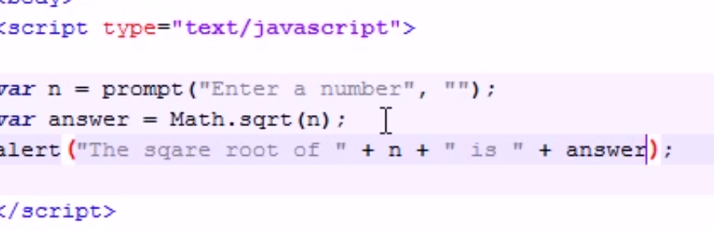
37. Beginner JavaScript Tutorial - 37 - Date Objects
    1. 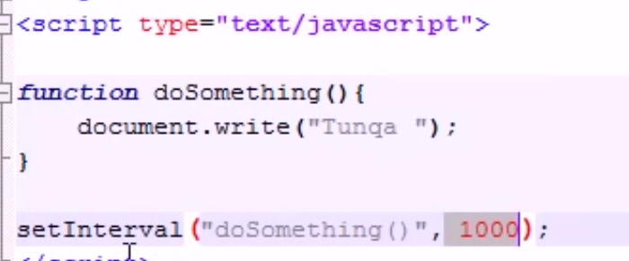
    2. Set interval function works like timer in java
    3. 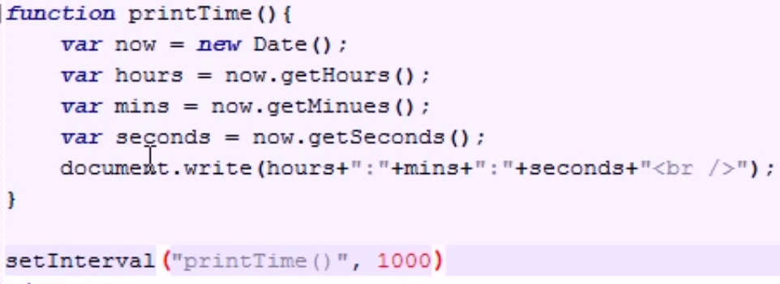
38. Beginner JavaScript Tutorial - 38 - Accessing Forms
    1. 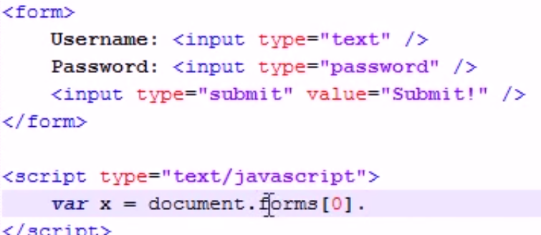
39. Beginner JavaScript Tutorial - 39 - Accessing Form Elements
    1. 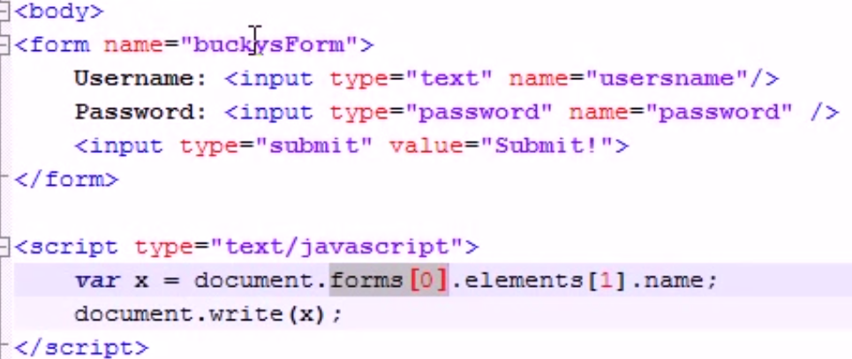
    2. 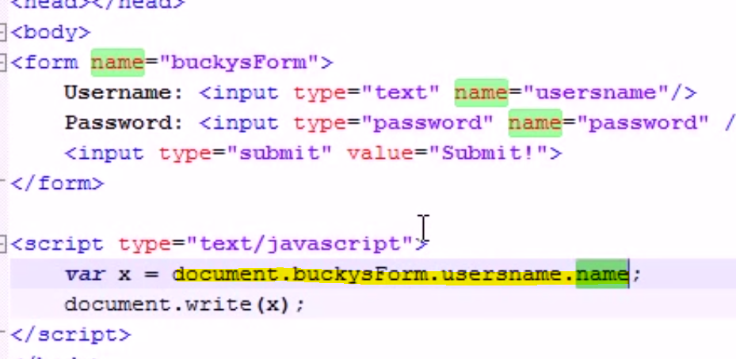
40. Beginner JavaScript Tutorial - 40 - Simple Form Validation
    1. 